1. **FOREST FIRE PREDICTION**

**ABSTRACT**

Identifying forest fire from the images of the forest is one of the interesting research areas in computer and disaster management field. This paper presents a survey of different image processing and machine-learning techniques used in the identification of forest fire based on the images of forest. This paper presents not only survey of various techniques but also concisely discusses important concepts of image processing and machine learning applied to forest fire detection and classification. We carry out detailed study of 19 papers, covering the work on forest fire and present a survey of these papers based on important criteria. These criteria include size of image dataset, no. of classes(forest), preprocessing, segmentation techniques, types of classifiers, accuracy of classifiers etc. We utilize our survey and study to propose and design our work on detection and classification of forest fire.

* 1. **INTRODUCTION**

A forest fire  is an uncontrolled [fire](https://en.wikipedia.org/wiki/Fire) in an area of combustible [vegetation](https://en.wikipedia.org/wiki/Vegetation) occurring in [rural areas](https://en.wikipedia.org/wiki/Rural_area). Depending on the type of vegetation present, a wildfire can also be classified more specifically as a brush fire, bushfire, desert fire, forest fire, grass fire, hill fire, peat fire, vegetation fire, or veld fire.

[Fossil](https://en.wikipedia.org/wiki/Fossil) [charcoal](https://en.wikipedia.org/wiki/Charcoal) indicates that wildfires began soon after the appearance of terrestrial plants 420 million years ago. Forest fire's occurrence throughout the history of terrestrial life invites conjecture that fire must have had pronounced evolutionary effects on most ecosystems' flora and fauna. Earth is an intrinsically flammable planet owing to its cover of carbon-rich vegetation, seasonally dry climates, atmospheric oxygen, and widespread lightning and volcanic ignitions.

Forest fire can be characterized in terms of the cause of ignition, their physical properties, the combustible material present, and the effect of weather on the forest fires can cause damage to property and human life, although naturally occurring wildfires may have beneficial effects on native vegetation, animals, and ecosystems that have evolved with fire.

**1.2 Objective Of Research:**

The Major objectives of the research are:

* To construct a database to alert for forest fire by information.
* To find out the forest fire based on continuous inputs of forest images using deep CNN.
* To build a database for forest fire prediction.

The rest of the paper is organized as follows:

1. Introduces the previous methodologies for forest fire identification in forest.

2. Section III briefs the system model of the proposed smart forest fire prediction & identification in forest.

3. Section IV outlines how the database is developed for storing the available forest fire management information.

4. Section V describes the implementation of the proposed system and the accuracy of the proposed methodology.

**1.3 Problem Statement:**

The proposed Forest Fire Prediction model is based sensor network incorporated to an alert system. The developmental approach of the proposed system includes two modules:

* Forest Fire Identification : Identification of fire affected areas.
* Forest Fire Management: Remedial measure for Forest Fire is all about detecting where the fire initiated in the forest.

1. **DATA COLLECTION**

The dataset was created by manually separating into different forest fire classes. We had consulted the forest officers and had asked them to provide details about the forest and the previous fire accidents.

This dataset was used for Detection and Classification of Forest Fire. As part of the work, the following activities were carried out (1) How to extract various image features (2) which image processing operations can provide needed information (3) which image features can provide substantial input for classification. The survey work is available in IEEE conference paper:

A Survey on Detection and Classification of Forest Fire, available at UCI repository. The detailed information is available in the published journal article: Detection and classification of forest fire, in Intelligent Decision Technologies, IOS Press.

**Source:**

[https://archive.ics.uci.edu/ml/datasets/Fire+Leaf+Forest](https://archive.ics.uci.edu/ml/datasets/Rice+Leaf+Diseases)

<https://cropgenebank.sgrp.cgiar.org>

<https://www.researchgate.net>

<https://www.alamy.com>

<https://www.shutterstock.com>

1. **METHEDOLOGY**

**A. Image acquisition**

Fire affected forest image is captured through a clear camera. To find the exact fire affected, the RGB color of the cropped image is must be clearly

visible as shown in figure 2. This is achieved with the help of a high end mobile camera. These images are stored in either of process able image extension in the database.

**B. Image preprocessing**

The basic idea of the procedure is to upgrade the picture information and enhance the image properties. Image pre-processing is basic for showing, putting away and transmission off picture. It brings about image improvement in forest fire picture using RGB shading

position as shown in figure 3.

**C. Image segmentation**

The image quality is affected by the intensity of camera, flash, external environment factors such as ambient light, frequency distortion etc. These factors act as noise in images. They can be removed by using the deep convolutional neural network CNN algorithm. The deep

convolutional network algorithm is used for noise reduction process of fire identification in forest. Using CNN provides the forest activist has an advantage of detecting fire sparks at early stages simply by exploring the complex features through camera. CNNs are adopted for fire identification in forest because of their highly automated feature learning techniques from the processed forest images. Low level forest fire images can also be identified using deep learning architectures. In the whole, for pattern recognition in forest images, the best classifications method is deep learning. Deep-CNN architecture proposed by Zaho et al.,[18] is a featured method designed for deep learning of image features. It constitutes a layer based convolutionaldeconvolutional model designed for deep learning of image features with Symmetric Skip Connections (SSC) between alternating convolutional-deconvolutional

Layers. The Continual linear and non-linear functions constitute the deep CNN. The linear functions are specifically expressed by convolution operations and the non-linear function expresses the complex operations. The convolution layer understands the local property of the forest fire images, and induces complex feature representations of forest fire. The deeper the model becomes, the greater the abstraction of forest fire Forest fire images. Input Preprocesse Enhancedd International Journal of Pure and Applied Mathematics Special Issue.

The basic form of the deep CNN productivity y is expressed as where x is the input, y is the output, Ci is the convolution matrix of the i-th layer, Zi is the bias of thei-th convolution layer, fi is a nonlinear function, and 􁆈 is the set of all tunable parameters including Ci and Zi . The objective of the deep CNN is to treasure an optimum parameter set with M input images to minimize the noising: X M m=1 D (ym, F(a, xm)).

**D. Image classification**

Several classification methodologies like Bayesian, artificial neural network [ANN], fuzzy classification. In the classification process, the forest fire Forest fire dataset is categorized into two sets, one to be training dataset and other the testing dataset. The training dataset is analyzed using deep CNN to extract its features and

Characteristics for comparison with the testing dataset. The testing dataset is a set of data whose features are to be analyzed and the forest is to be classified. The classifier performs analysis on the testing dataset and classifies based on the comparison with the training

Dataset. For distinguishing an infection, forest fire plant ailments highlights are extricated utilizing SIFT from the info pictures for the three sickness classes. In the preparation stage, seven dimensional component vectors are removed from each unhealthy picture and is given as contribution to the classifiers. The seven highlights are x position, y position, scale(sub-level), size of highlight on picture, edge hail, edge introduction, ebb and flow of reaction through scale space. For preparing, seven highlights for every maladies are separated, however number of key point shifts and it relies upon the picture many-sided quality.

**4.1 Exploratory Data Analysis:**

**4.1.1 Figures Data Analysis**

Forest fire Identification:

The Forest fire identification process depicted is implemented with the help of mobile application.It is a four step process namely:

1) Image capture & selection

2) Image zoom and crop,

3) Upload image and

4)Receive notification. Image capture & selection:

Fire affected forests image is captured through a clear camera. Multiple snapshots are to be taken for choosing the appropriate affected area. A clear image is chosen such that the fire affected areas are clearly visible. In case of same crop problem, choose images from the database which was created earlier; Image Zoom and crop: Choose the best portion of the Forest fire affected image and crop it; Upload Image: Cropped image is to be uploaded in the remote server using the mobile app; Receive notification: Once image has been uploaded in the remote server, pattern matching is performed with the available datasets using pattern matching algorithm, and the precaution is send to the forest officer via mobile app by the expert.

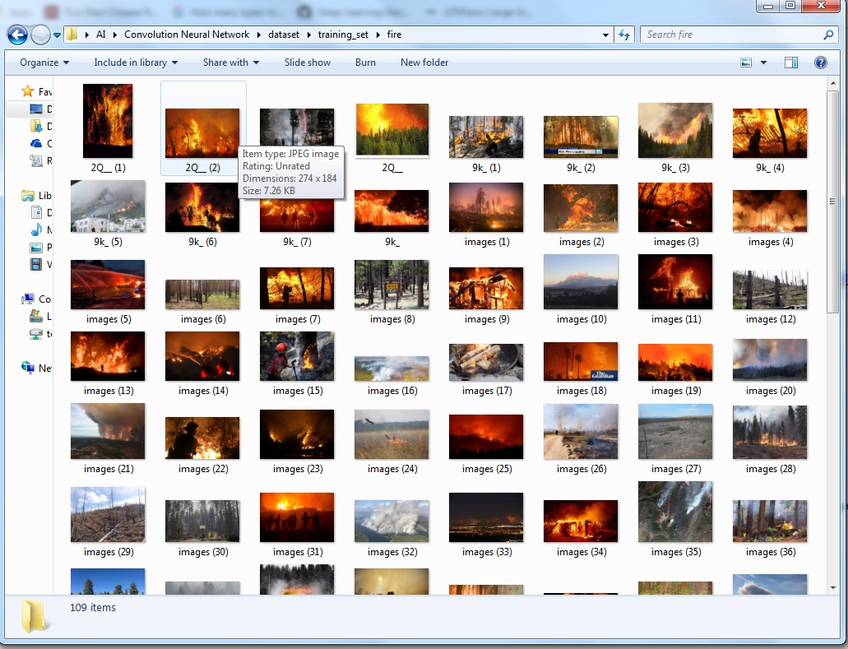

*FIG 4.1 (dataset for forest fire)*

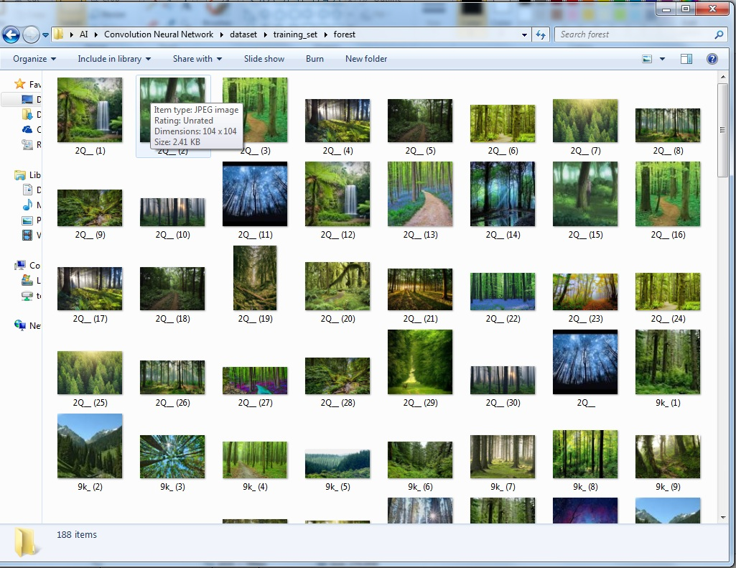

*Fig 4.2 (dataset for forest)*

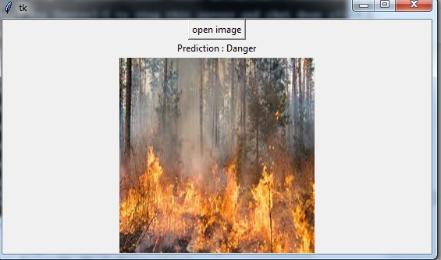

*Fig 4.3 ( prediction of forest fire)*

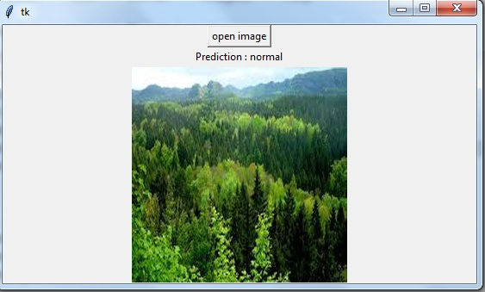

*Fig 4.4 (maintaining of safety)*

**4.2 Data Modelling:**

Algorithm: Forest fire classification using deep CNN.

***Input***: Forest fire colored Forest fired images.

***Output***: Classified Forest fired images & Preventive Measures.

**Step 1**: Start.

**Step 2**: Train the 200 selected images with deep CNN and obtain the features for pattern matching.

**Step 3**: Select the colored image of a specific Forest fire from testing database.

**Step 4**: Crop multiple Forest fired spot from the image and choose the ideal one.

**Step 5**: Apply deep CNN algorithm for images denoising

**Step 6**:Apply color and texture feature extraction

**Step 7**: Train the color and texture feature with classifier

**Step 8**: Determine and classify the images using deep CNN

**Step 9**: Highlight the Forest fire affected and remedial measures

**Step 10**: Stop.

Among the 200 Forest fired images, number of truly detected Forest fire images for Blast, Brown spot, Bacterial leaf blight (BLB), Sheath blight, false smut, Root knot nematode and White tip Forest fired identified were only 175 under various category. The detection success rate for considered forest fire crop Forest fire affected images is 87.50%. The proposed methodology ( Deep CNN ) is compared with the previous approach which was implemented by combining k-means & fuzzy logic classifier and CNN classifier.

1. **References**

[1] Savakar D G. and Anami B S, Improved Method for Identification and Classification of Foreign Bodies Mixed Food Grains Image Samples, International Journal of Artificial Intelligence and Machine Learning, Vol.9, Issue.1, 2009, pp.1-8.

[2] Vibhute A. and Bhode S K, Applications of Image Processing in Agriculture: A Survey, International Journal of Computer Applications, Vol. 52, Issue. 2, August 2012, pp.34-40.

[3] Landge P S., Patil S A., Khot D S., Otari O D. and Malavkar U G, Automatic Detection and Classification of Plant Forest fire through Image Processing, International Journal of Advanced Research in Computer Science and Software Engineering, Vol.3, Issue.7, July 2013, pp.798801.

[4] Barbedo J C A, Digital Image Processing Techniques for Detecting, Quantifying and Classifying Plant Forest, Springer Plus, Vol.2, Issue.660, 2013, pp.1-12.

[5] Rathod A N., Tanawal B. and Shah V, Image Processing Techniques for Detection of Leaf Forest fire, International Journal of Advanced Research in Computer Science and Software Engineering, Vol.3, Issue.11, November 2013, pp.397-399.

1. **CONCLUSION**

The drastic environment change urges the need of devising new methodology for agriculture i.e. forest fire crop plantation. In this paper, we proposed a new mobile app based on ML algorithms for defining forest identification and classification in forest fire crops. The deep CNN is used for denoising images classification is used for Forest fire classification. The work major concentrates on Forest fire. In the selected 500 images, denoised images are trained with the deep CNN a classifier and their features are taken for pattern matching; remaining 200 images are used for testing. The proposed methodology (Deep CNN classifier) is compared with the previous approaches which were implemented by combining k-means & fuzzy logic classifier and KNN. It is found that the proposed methodology has evidenced to achieve improved classification with an accuracy of 87.50 %. The research work can further extended to reduce the false classification by using other classifiers for feature extraction among the various forest fire .